Ballast Questions and Pictures

Mr. Artimovich: Sandbags have the tendency to break apart and then we are left with loose sand on the ground/pavement and a potential hazard for vehicles, especially motorcycles. Would the following ballast types and implementation be acceptable to be use within our work zones?

Inner Tube Ballasts:
- Inner tube ballasts can be custom fit to our needs and can fill the tubes with manageable sizes/weights for our diverse employees. They will also not deteriorate and leave sand on the roadway.
- The height of the inner tube ballast is comparable to that of typical sand bags. The weight is easily varied for different needs. The tubes can be made individually as shown are 5 ¼” tall by 15”. The entire tube can be used to make two units filled with sand but remain attached with a 3” gap, which is 33” long, but this can be easily varied.
- Field study result: The inner tube ballast remained in place and held the sign legs in place throughout the day.
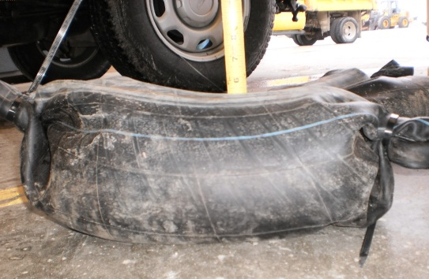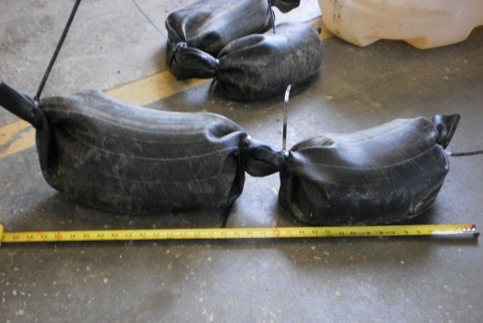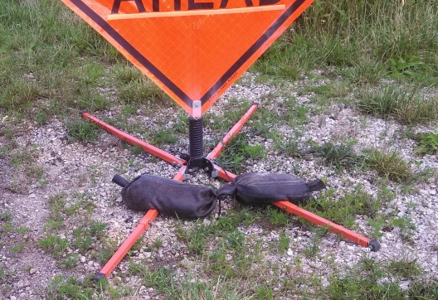

Trim-line Channelizer Ballasts:
- The trim-line channelizer ballasts are readily available. They can be placed over the post of the sign stand.
- There are two different size ballasts. The octagon shaped one is 17 ½” across 2” thick and weights 16 lbs. The rectangle shaped ballast is 14” wide x 24” Long x 2” thick and weights 24 lbs.
- The notch we cut to slide past the spring area of the easel is approximately 4” wide and this allows the breakaway of the easel (spring) to fold over all the way to the ground if necessary.
- The ballasts can be added to the easel without having to remove the sign from the easel.
- MoDOT likes the trim-line ballasts because they are easy to handle and still be used as a trim-line channalizer ballast.
- Field study result: We have used these in the past when sand bags were unavailable which we had good luck with just using one of the octagon shaped ballast in 20 mph winds.
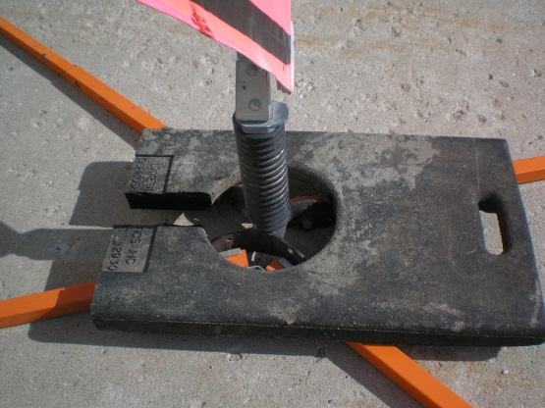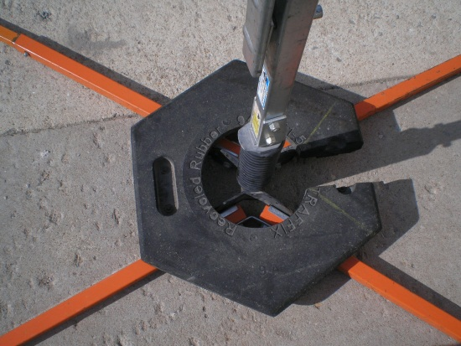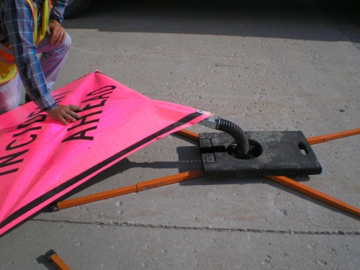

Drum-like Channelizer Ballasts:
- The drum-like channelizer ballasts are readily available. They can be placed over the post of the sign stand, or placed on the legs of sign stand.
- The dimensions are 35” OD, and 21 ½” ID, weighing approximately 15 lbs.
- Field study result: The drum-like channelizer ballasts remained in place and held the sign legs in place throughout the day.
