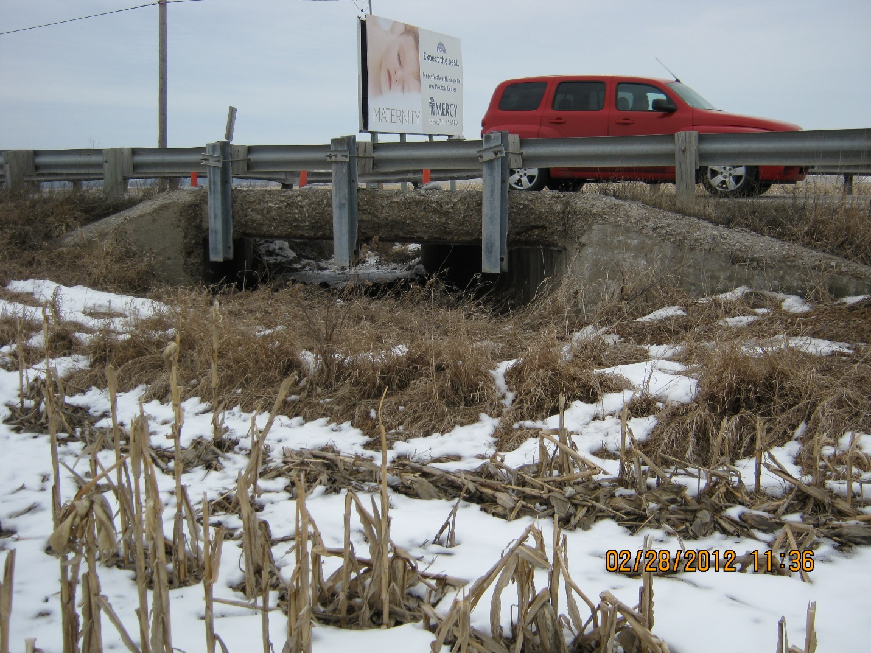
West side of box. Looking east
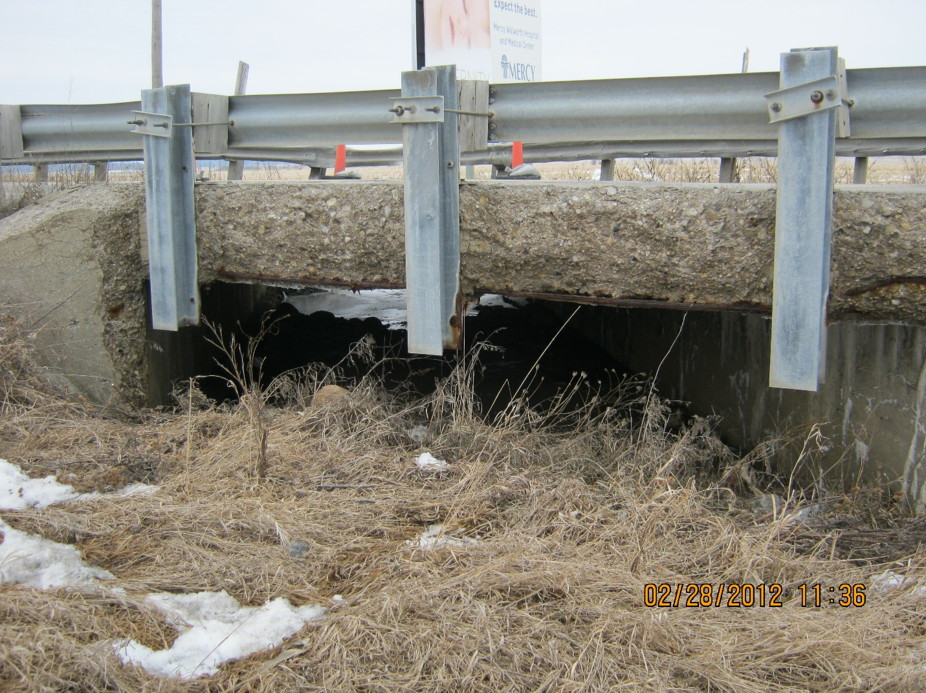Close up of west side of box.

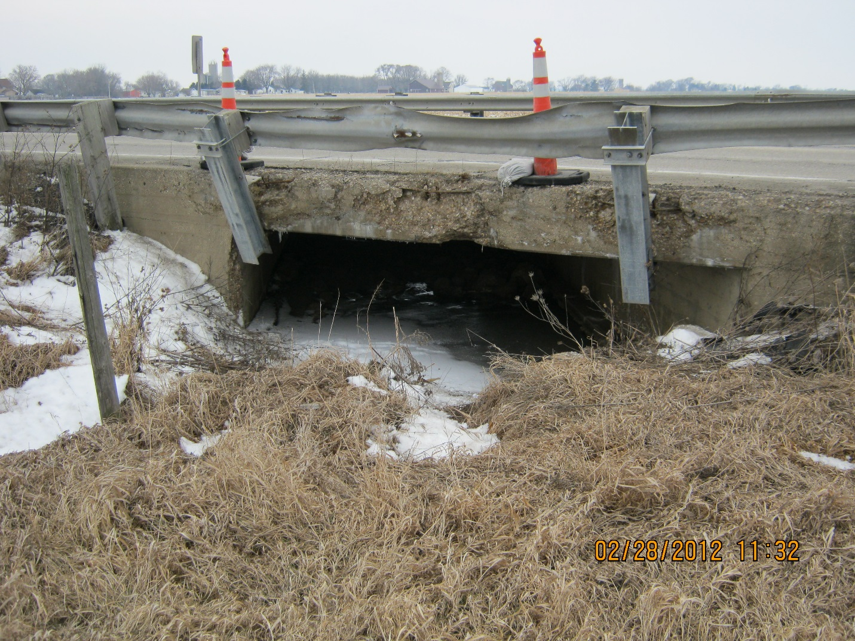East side of box. Looking west. Damage after semi hit guardrail. Was repaired in 2012.
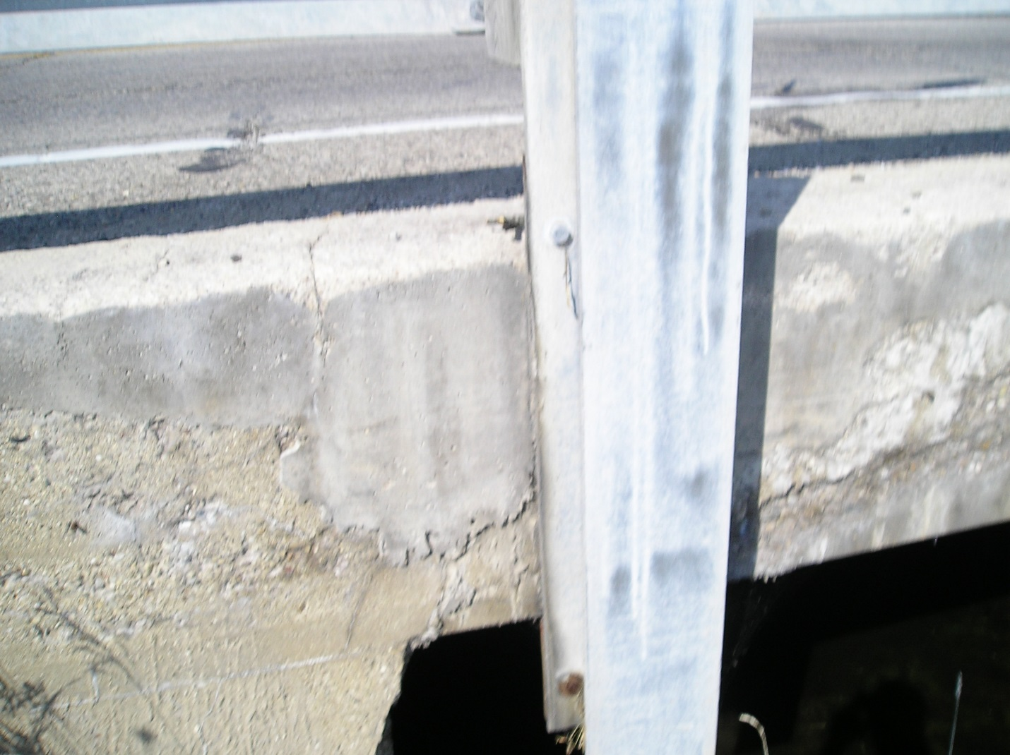
East side of box. Repaired and guardrail reattached.

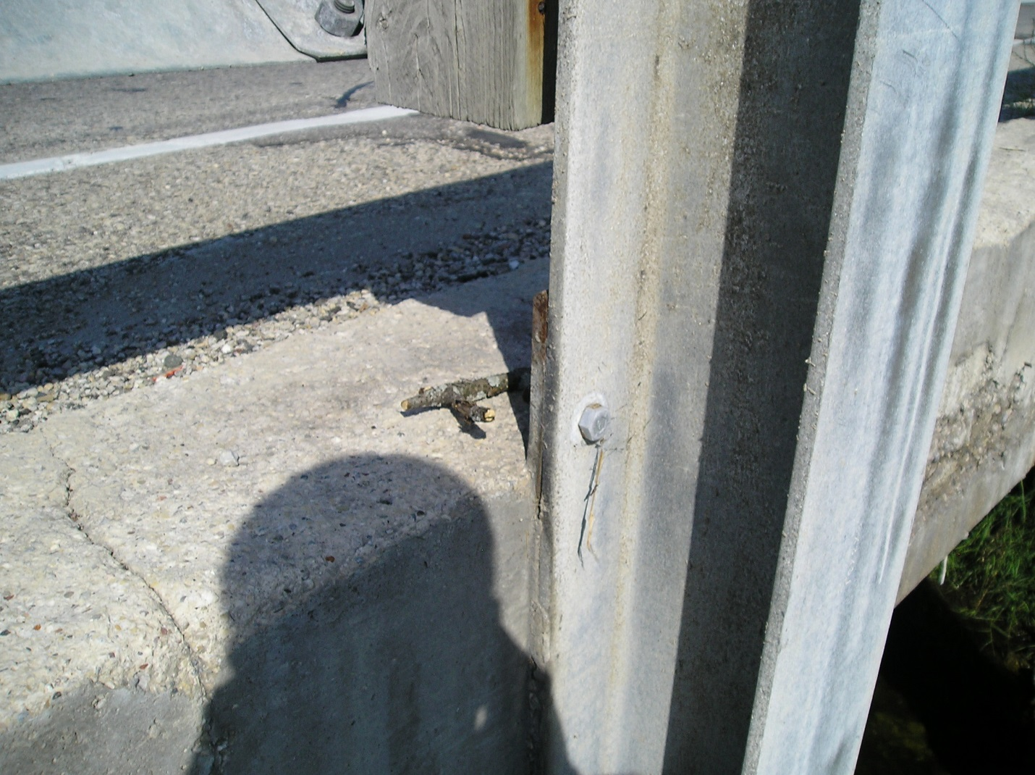
East side of box. Repaired and guard rail reattached.

