Guardrail Clearance Distance

Figure x.x.x Guardrail Clearance Distance

The guardrail clearance distance is a horizontal distance measured from a line connecting the back of guardrail posts to the nearest point of the obstruction. Table x.x.x shows the desirable and the minimum clearance distances for different post spacing of the MGS. Table x.x.x shows the clearance distances for the previous (or retired) standard guardrail systems.

- The desirable distance should be provided unless a cost-effective analysis shows that it is not economical to do so.
- Obstructions should be positioned to minimize the use of close post spacing.
- Storage of material and equipment behind guardrail during construction shall be placed so that the desirable clearance distance is provided.

Table X.X
Guardrail Clearance Distance
Guardrail  System | Post Spacing | Minimum Design  Clearance Distance | Minimum Desirable Clearance Distance
MGS- 31”  Type A | 6’- 3” | 28”(*) | 42”
MGS- 31”  Type B  ½-Post Spacing | 3’- 1 ½” | 23”(*) | 30”
MGS  ¼-Post Spacing | 1’-6 ¾” | 14”(*) | 24”
(*) Minimum design clearance distance to be used only when desirable dimensions cannot be obtained.

Table X.X
Guardrail Clearance Distance
Guardrail  System | Post Spacing | Minimum Design Clearance Distance | Desirable Design Clearance Distance
Retired Standard- 27½”  Type A | 6’- 3” | 36” | 36”
Retired Standard- 27½”  Type B  ½-Post Spacing | 3’- 1 ½” | 24” | 24”
Retired Standard- 27½”  ¼-Post Spacing | 1’-6 ¾” | 18” | 18”

Guardrail Post Spacing Transitions

In locations where existing obstructions cannot be offset further from the roadway to obtain the minimum required guardrail barrier clearance distance, stiffer guardrail transitions shall be accomplished through reduced post spacing. For all new installations, obstructions shall be no closer than the minimum desirable clearance distance. When the minimum design clearance distance is not obtainable, a design deviation shall be submitted to the Tollway’s Chief Engineer for consideration.

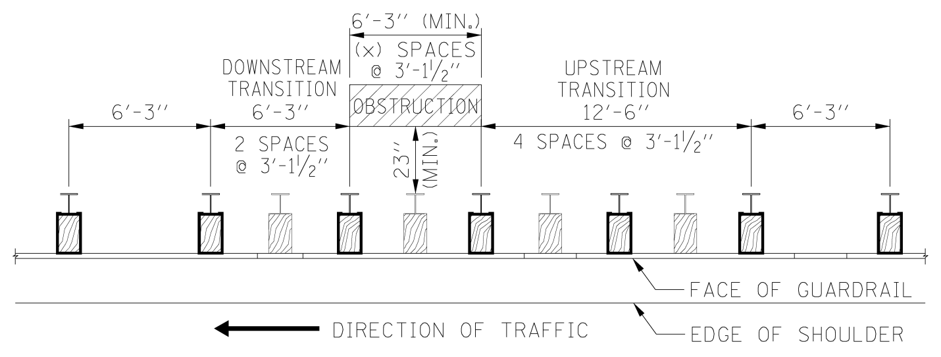

Figure 4.2-2 Guardrail Post Spacing Transition to ½-Post Spacing

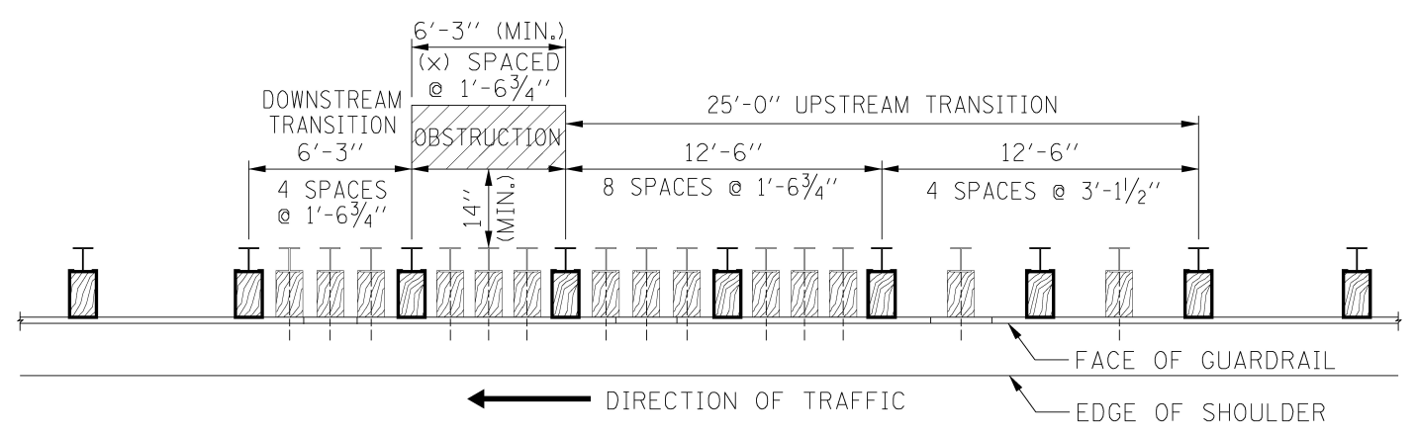

Figure 4.2-3 Guardrail Post Spacing Transition to ¼-Post Spacing

For any obstruction with a horizontal clearance distance of less than 14”, a concrete barrier wall shall be installed. Double nesting of the w-beam rail elements to stiffen the guardrail is not permitted.

Guardrail Posts Conflicts with Drainage Structures

It is not permissible to leave out any posts. Also, additional block-outs are not to be added to provide a greater offset, in order for the post to avoid an obstruction. Block-outs shall not be omitted. For Type A Guardrail, maximum post spacing shall be 9’-6” and minimum post spacing shall be 3’-0”

For Type A guardrail (6’-3” post spacing) and a drainage structure conflicts with one post.
- Move conflicting post to the side of the structure that maintains the most even post spacing. Do not exceed maximum post spacing.
- If maximum post spacing cannot be maintained, then move conflicting post to be adjacent to drainage structure and add one post to be adjacent to the other side of the structure. Posts should be no closer than the minimum spacing. If minimum post spacing cannot be met, then next adjacent post shall be moved to achieve the minimum post spacing. Keep post spacing as uniform as possible to reduce the potential for vehicle pocketing because of the abrupt changes in rigidity. Because the deflection of the rail will be increased in areas where post spacing is increased, the guardrail clearance distance shall be 6’ minimum to any nearby hazards.

For Type A guardrail (6’-3” post spacing) and a large drainage structure conflicts with two posts.
- Move conflicting posts to be on each side of structure.
- Post spacing shall not exceed maximum post spacing and shall not be less than the minimum post spacing.

